1. **Region and Domain**

India

COVID-19(India)

**2.Research question**

Which Indian states have the highest**(Death Toll, Infection Fatality Rate,**

**Case Fatality Rate** and **Recovery Rate)** after one year of COVID-19?

1. **Link**

<https://www.kaggle.com/sudalairajkumar/covid19-in-india>

1. **Images**

Top 10 Indian States with highest Death Toll.

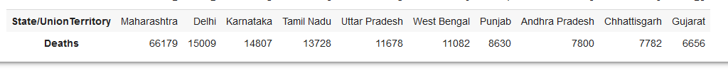

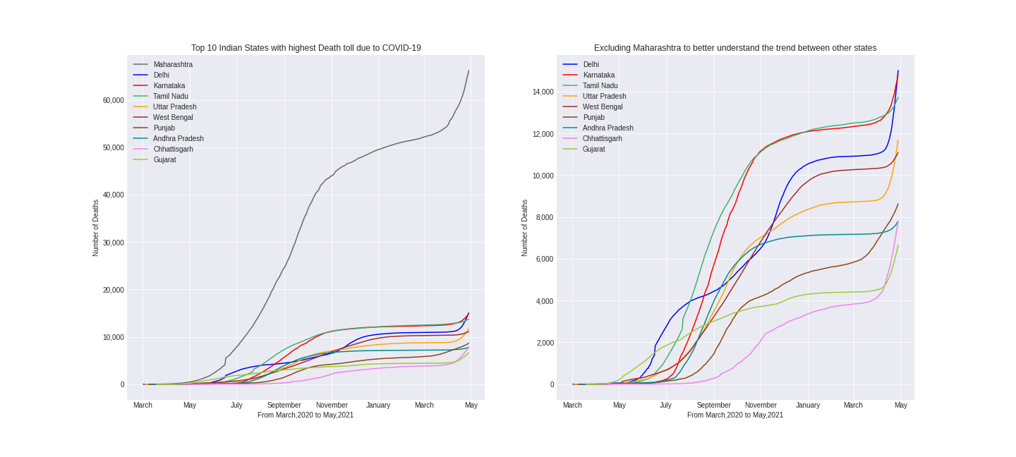

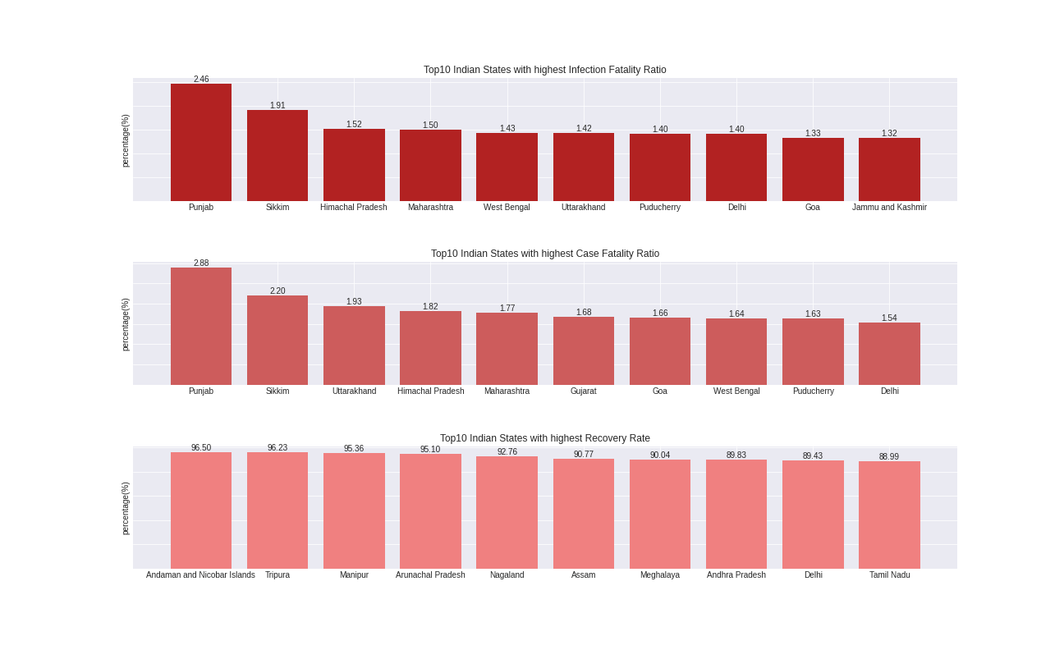

1. **Discussion**

These figures presents visualization representing Top10 Indian States with the highest Death Toll(and the trend between them), Infection Fatality Rate, Case Fatality Rate , Recovery Rate. Data for this analysis was takes from Kaggle. India is one of the few countries highly affected by Covid-19 and this Analysis help us to better understand which Indian States are more affected by Covid-19 and which are showing the highest recovery rate.

This data is from March,2020 till 27th April,2021, which is almost a month more than a year. Maharashtra is the Indian state with the highest death toll of 66,179 followed by Delhi with a count of 15,009, a big difference of 51,170 can be seen. Death rate in most of the states remained stagnant from December,2020 till March,2021 ,but a sudden rise can be seen in the month of April. From this Analysis we understand rising deaths and fatality ratio in India.